A small quirk related to QGIS “Save As” component

Choose to “Save As” (capture 1, below)
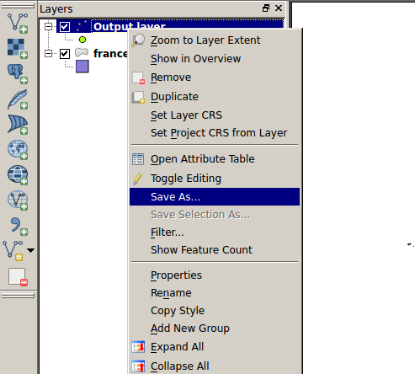
I choose a “Format” in the list like below (capture 2)
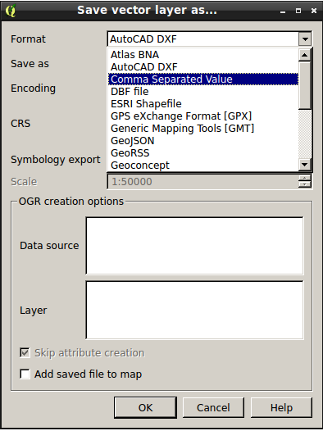

After I do “Browse” at the right part of “Save as” and I see following image (capture 3)

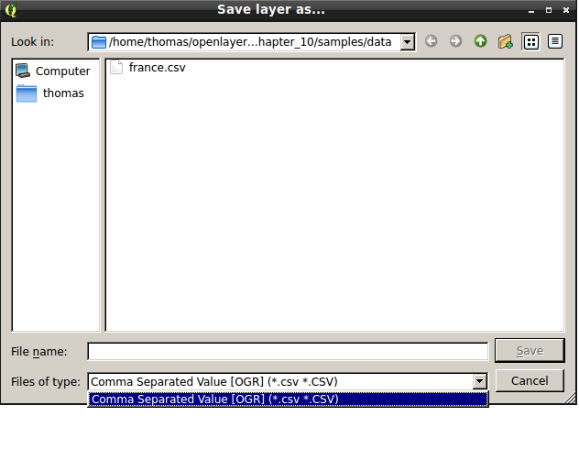

What I see is that I have a list with no choice for other layers types.
So, this drop-down list is really not useful. We don't need to have a choice that can confuse users and/or don't have any value.

To improve, different choices:
*choose to remove the unique choice in capture 3
*choose to only display the unique choice in capture 3 (but as text not as a drop-down list)
*choose to display all vector layers types to choose in capture 3
*choose to display all vector layers types to choose in capture 3 and remove Format options in capture 2

